**LAB 3 Assignment**

1)Make a Mashup application including various services (e.g., Google Map, Google Chart, Google Search, Yahoo, Amazon, Twitter, Facebook)

I created a mashup application which includes Google Maps, Google Chart, Twitter, Facebook api’s.

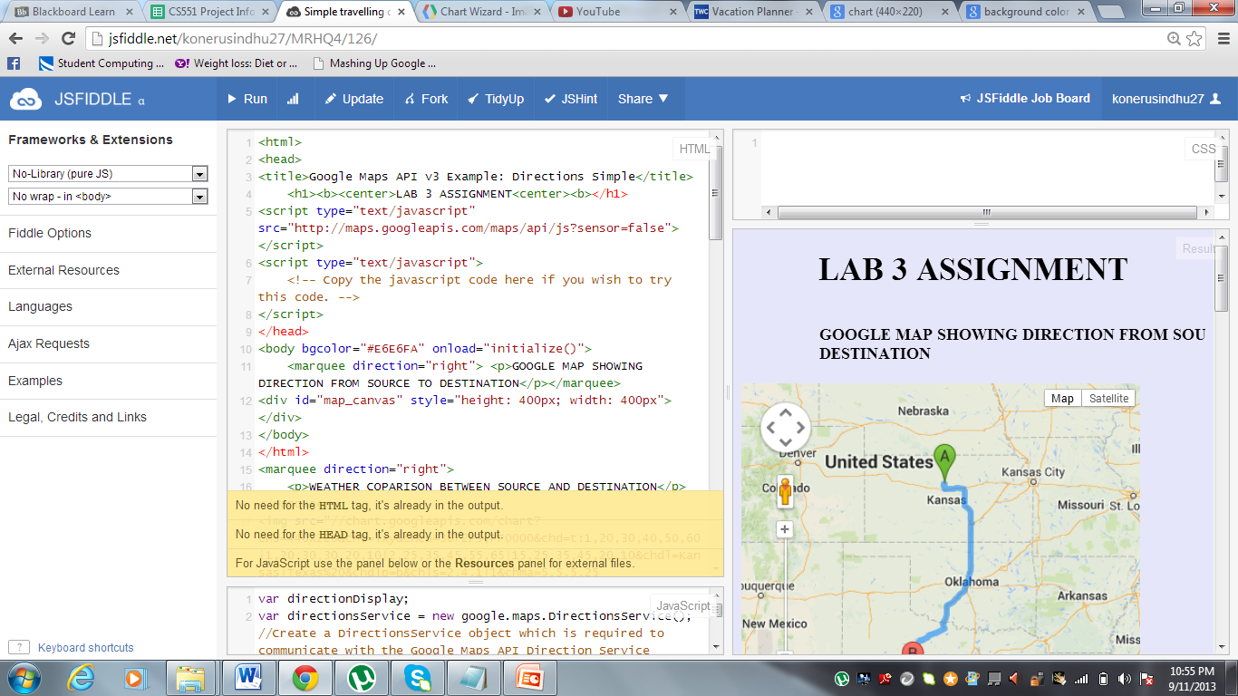

If we gie the name of the source and destination.It shows the direction to the destination in google maps using google maps api.

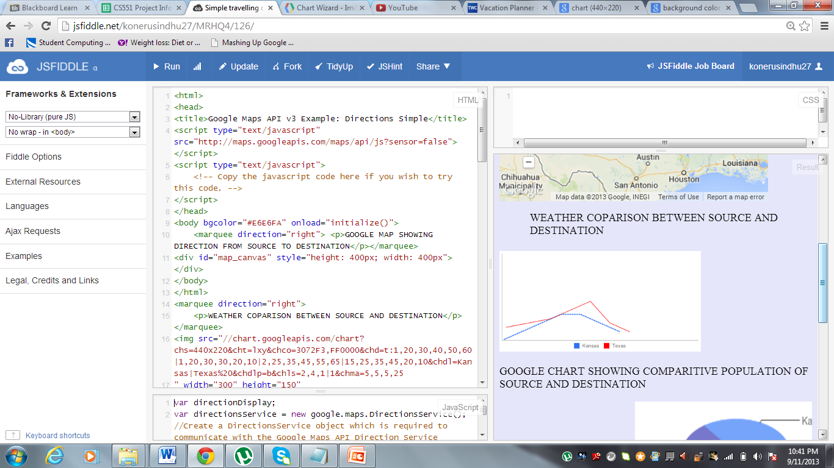

Then the comparison between the weather of source and destination are shown using a graph.

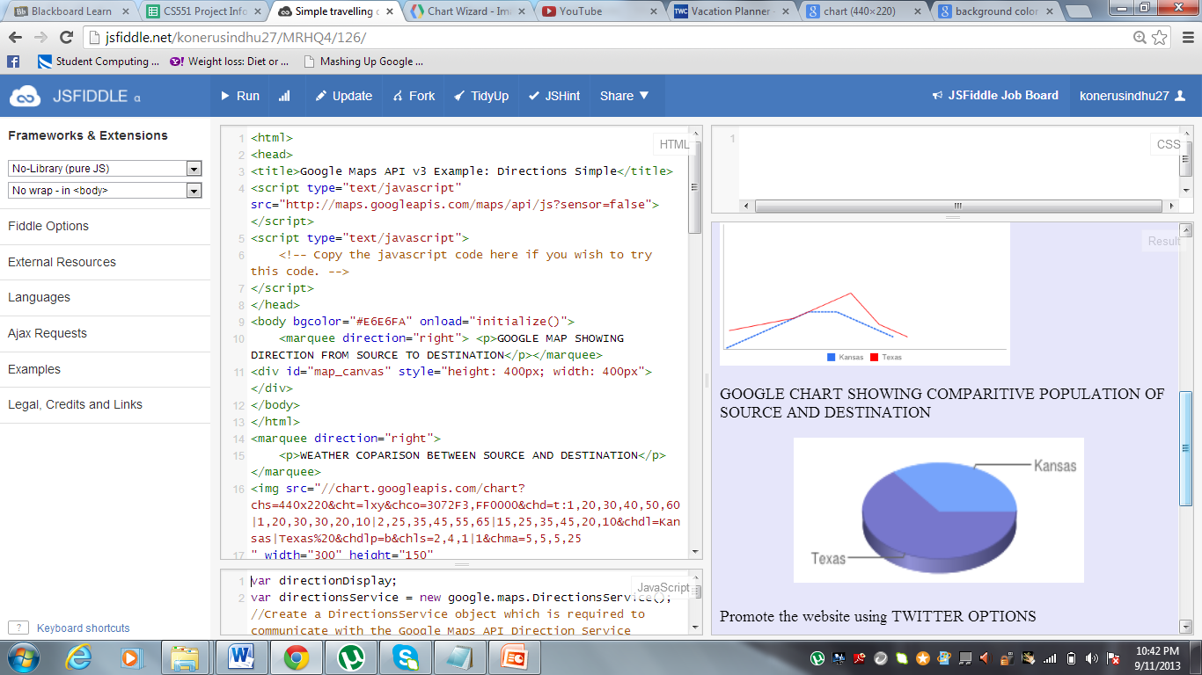

The percentage of population between the source and destination is also shown.

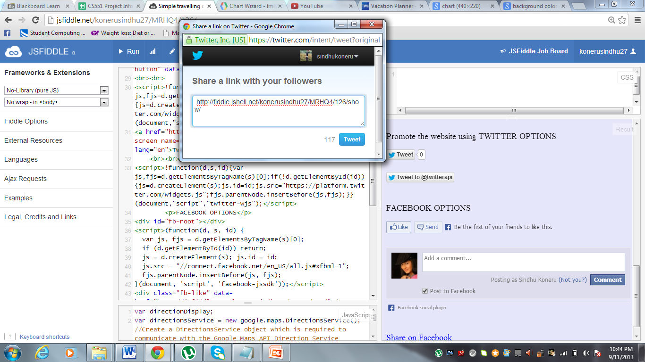

We can login in our twitter account with this application and we can tweet and advertise this application.

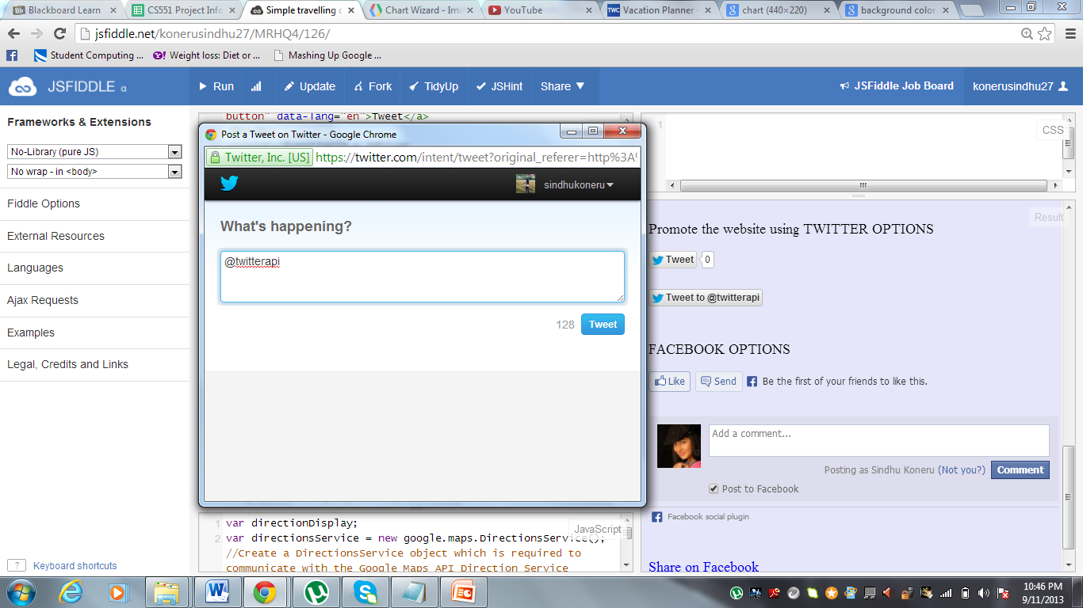

We can directly tweet to @twitterapi using tweetto@tweetapi option.

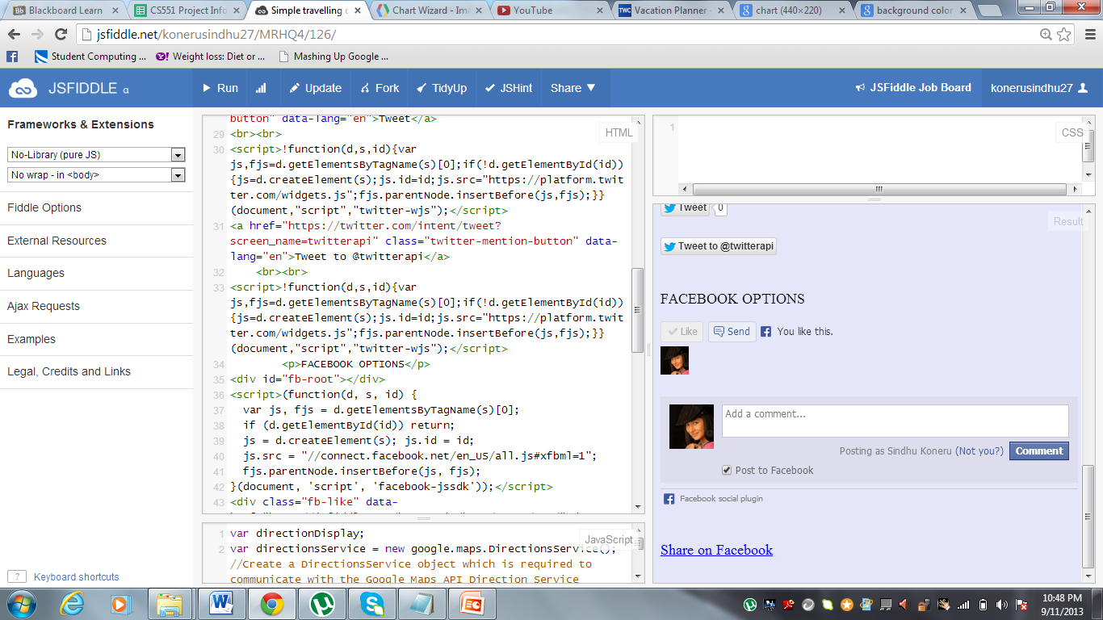

Using the like button we can **like the website** using our login.

We have an option to **send the messageto** any one of our friends using send button.

We can also comment using the **facebook comment** option.

Then we have **share on facebook** option where we share the link of this web site on the facebook thus,it helps for promotion.

<http://jsfiddle.net/konerusindhu27/MRHQ4/126/>

2) i) Install IIS Server on BM Cloud instance, ii) deploy the service in Tutorial 5 package to your instance as shown in Tutorial 5, and iii) access the service from your client.

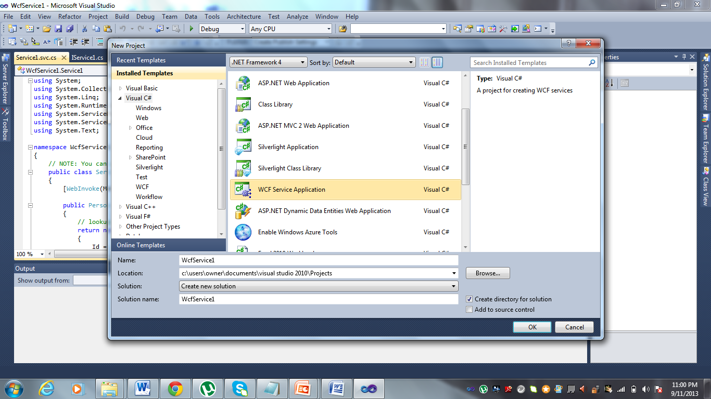

Opening a WCF application

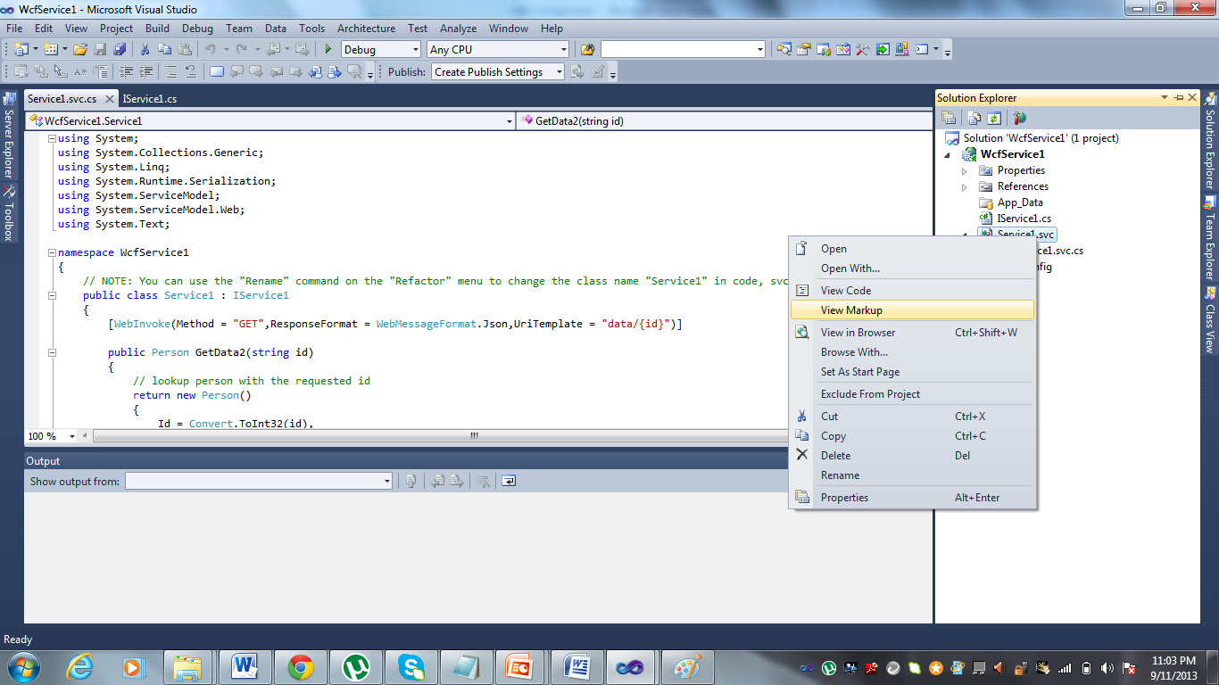

Checking the markup in view mark up.

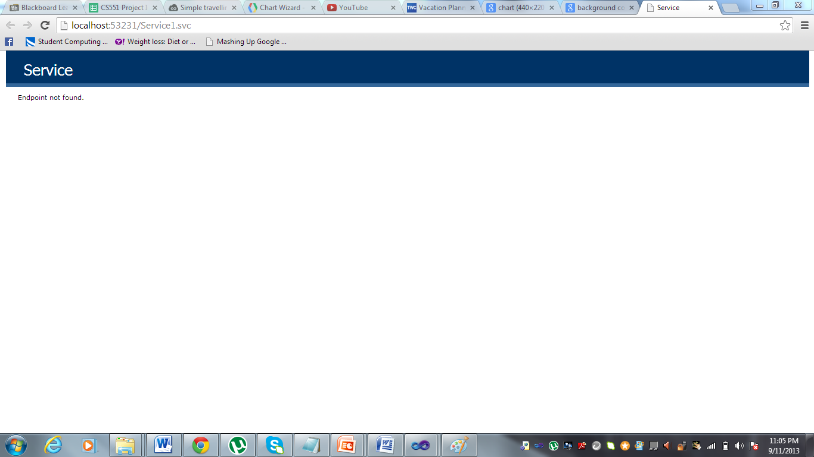

We will have end point not found message.

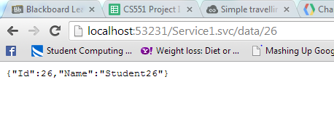

Then if we give the data/id then the following will be printed.

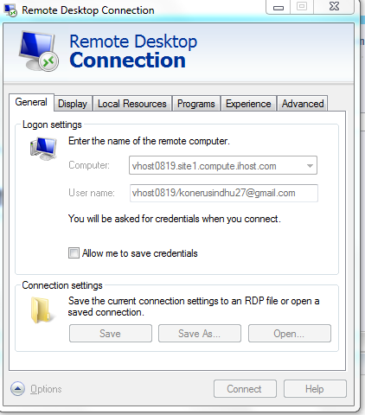

Goto remote desktop and then give the computer as the host name of instance in IBM cloud instance and the username.

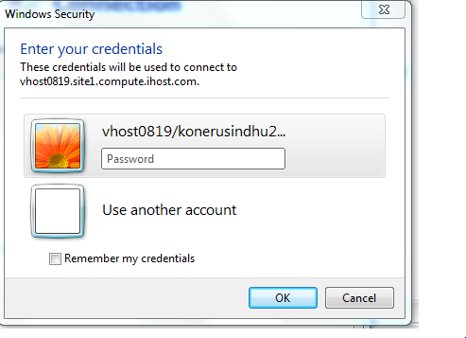

Then the password will be asked to login then give the password.

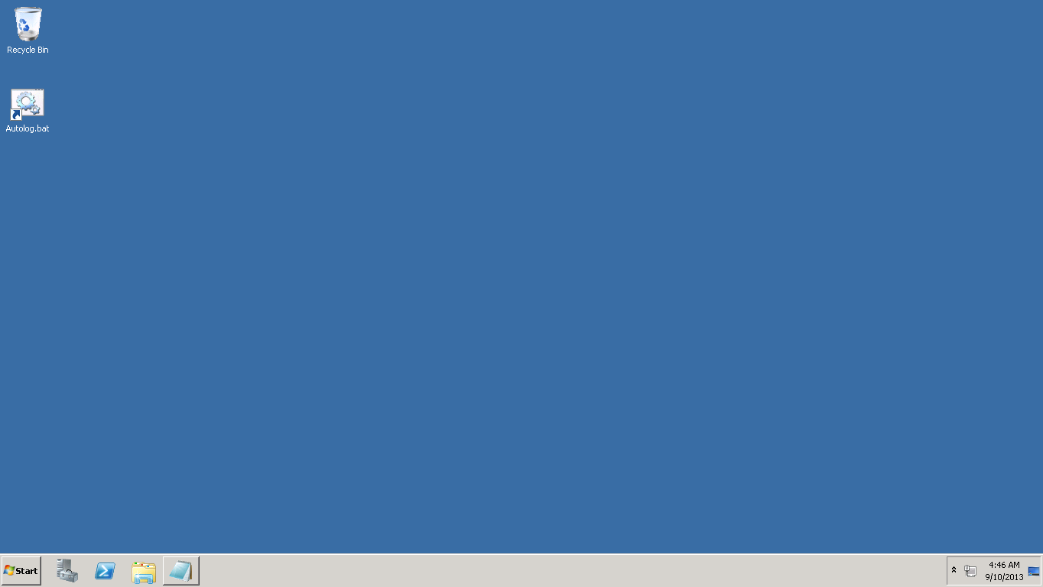

You will be logged into remote login

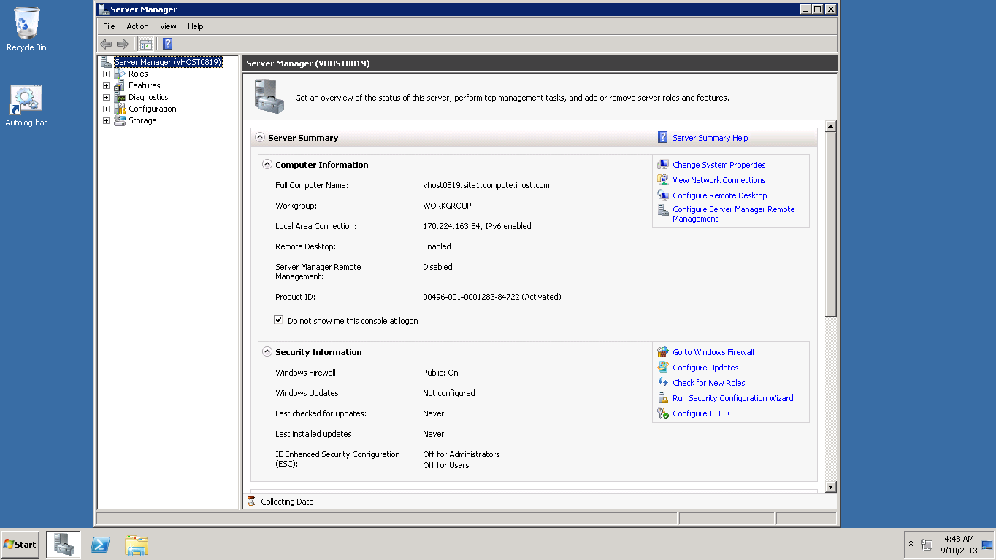

This is the server manager.

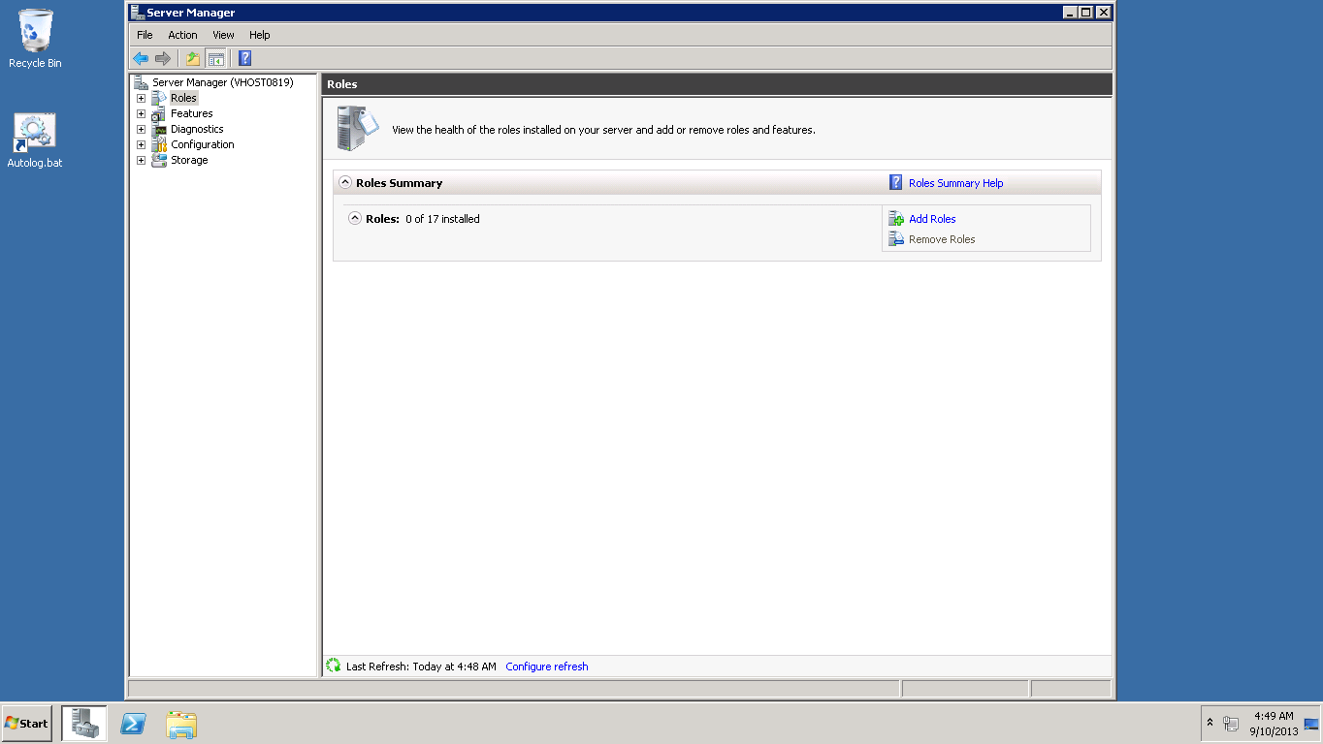

Add roles in the server manager.

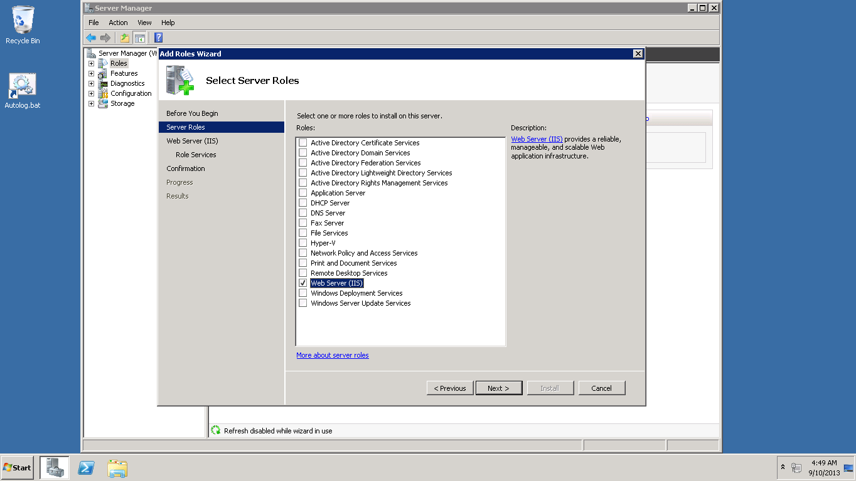

Web ser iis is marked and added.

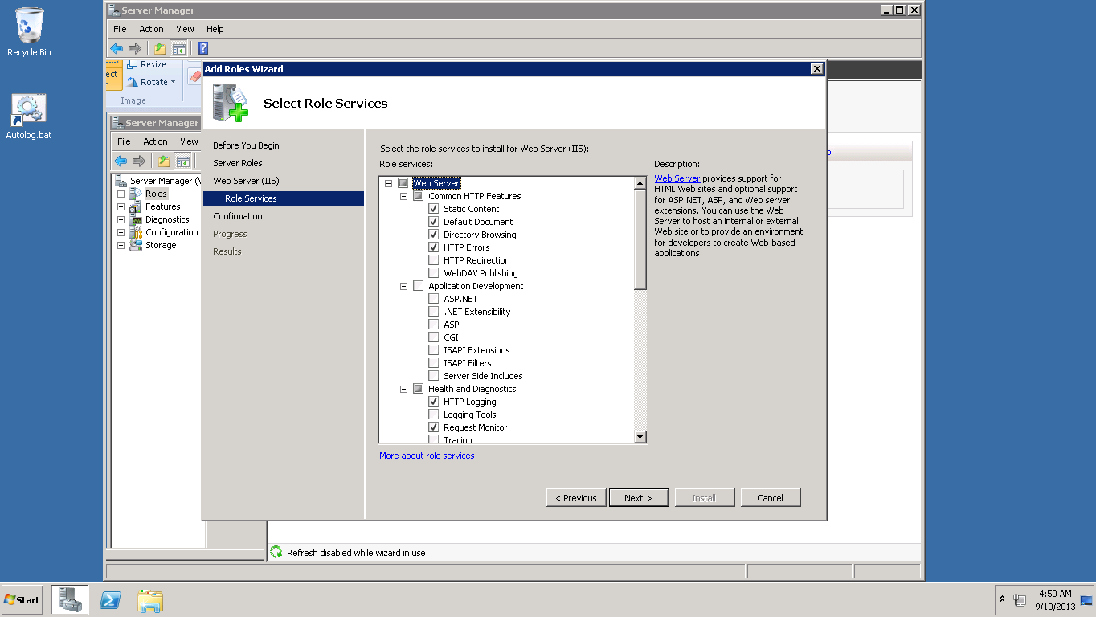

In role services the above services are marked.

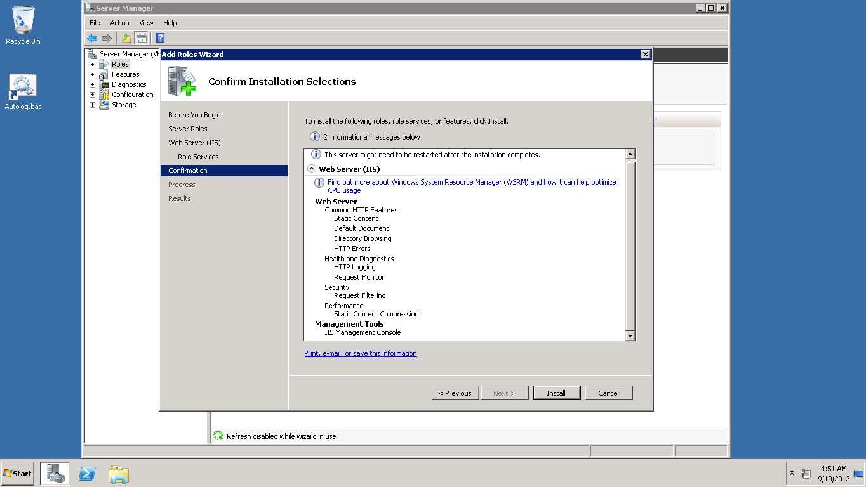

Install button is clicked.

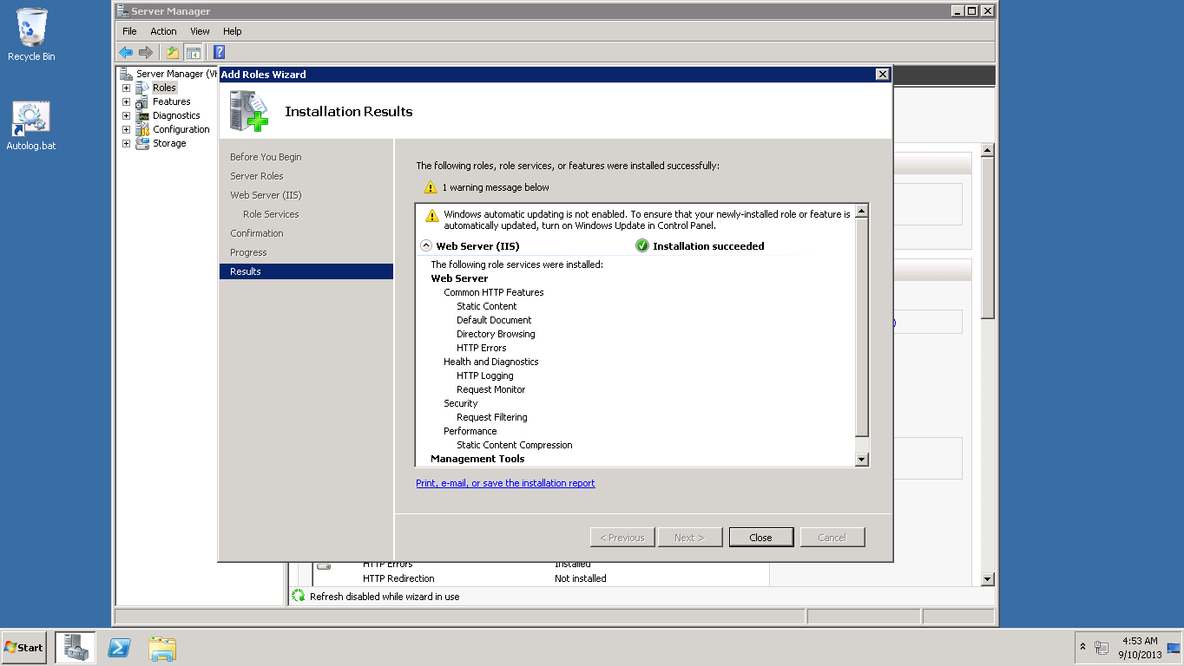

Installation succeded.

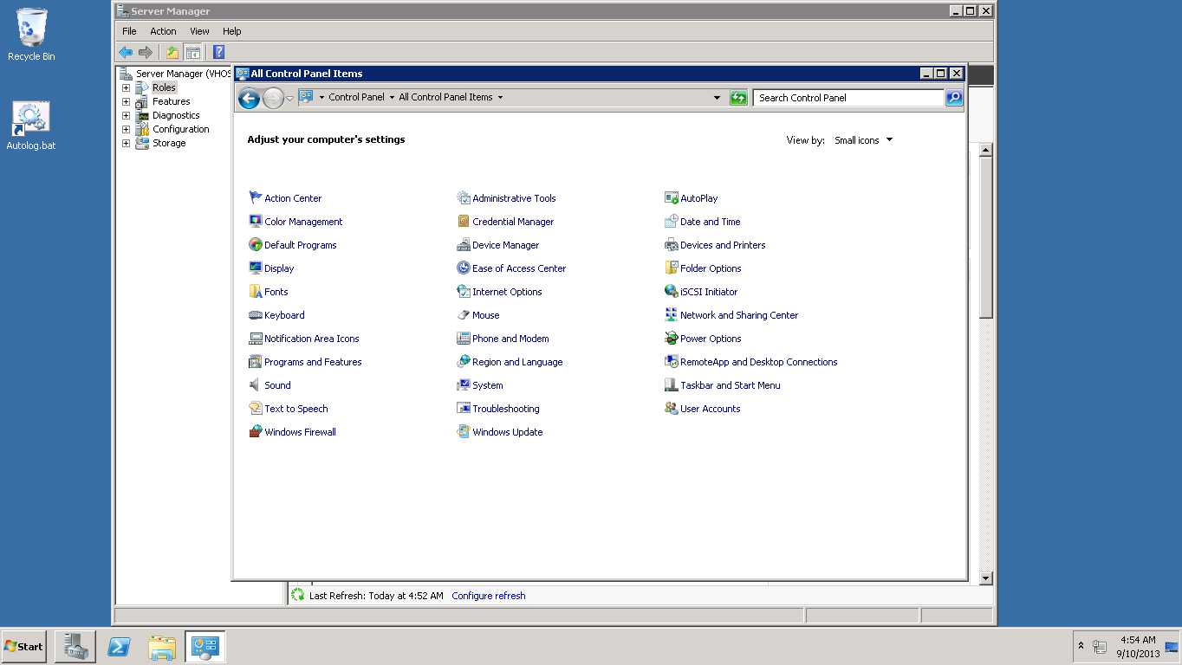

Firewall settings are set correctly.

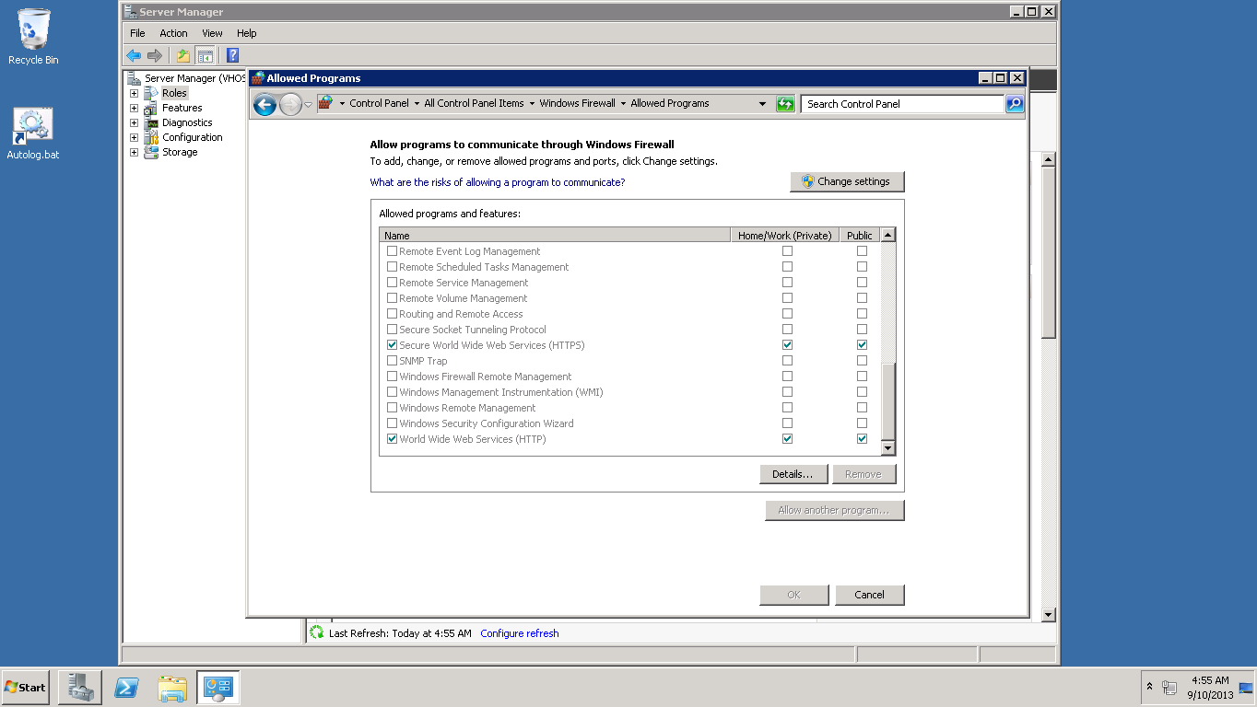

Allowing the programs to communicate through firewall.

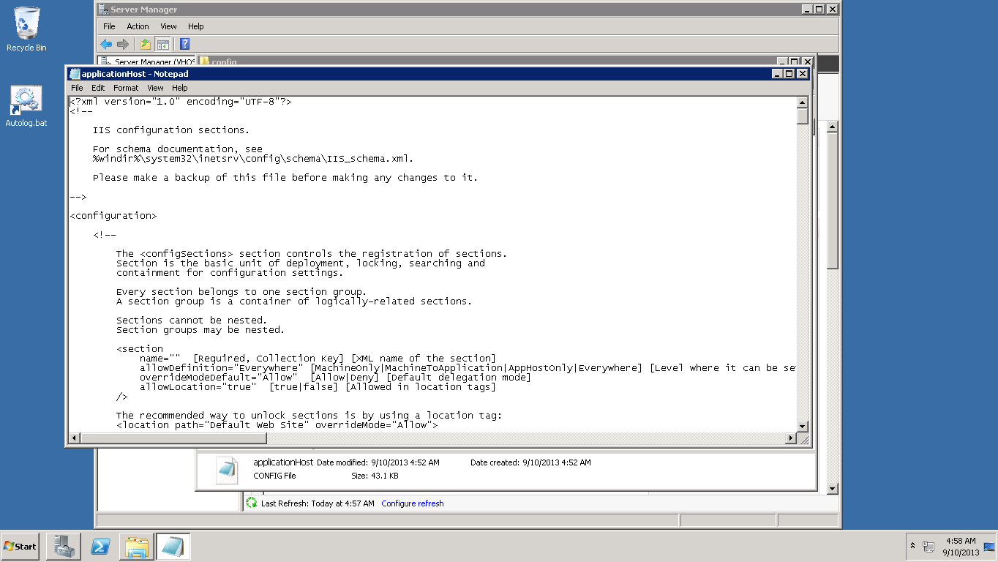

Changing application host as we want.

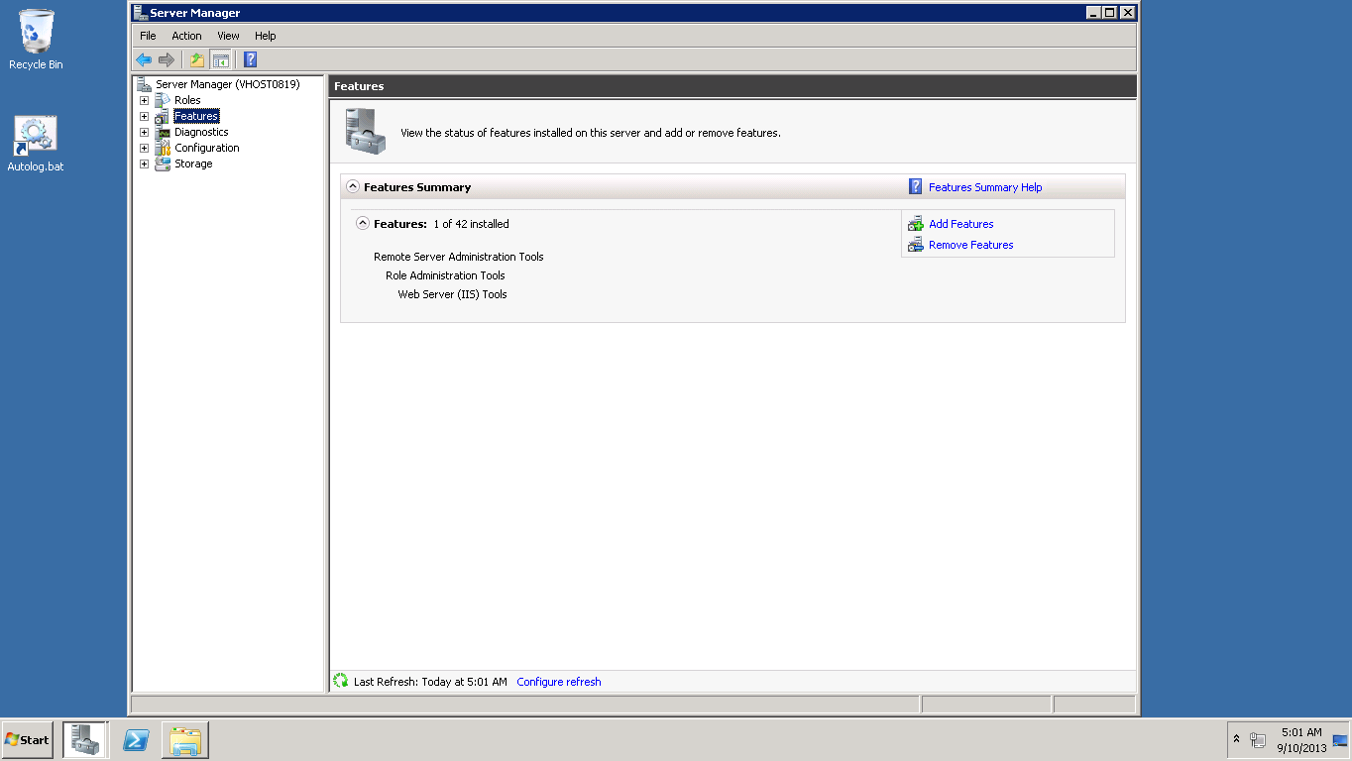

Adding features.

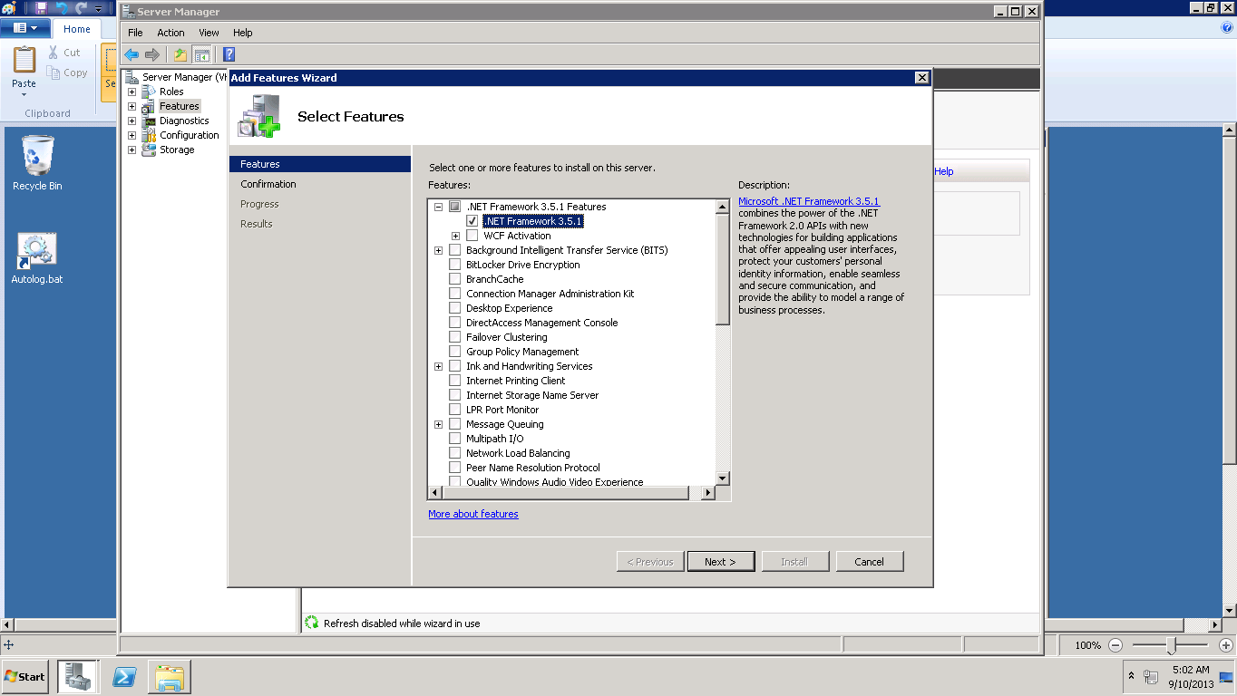

Selecting the required features.

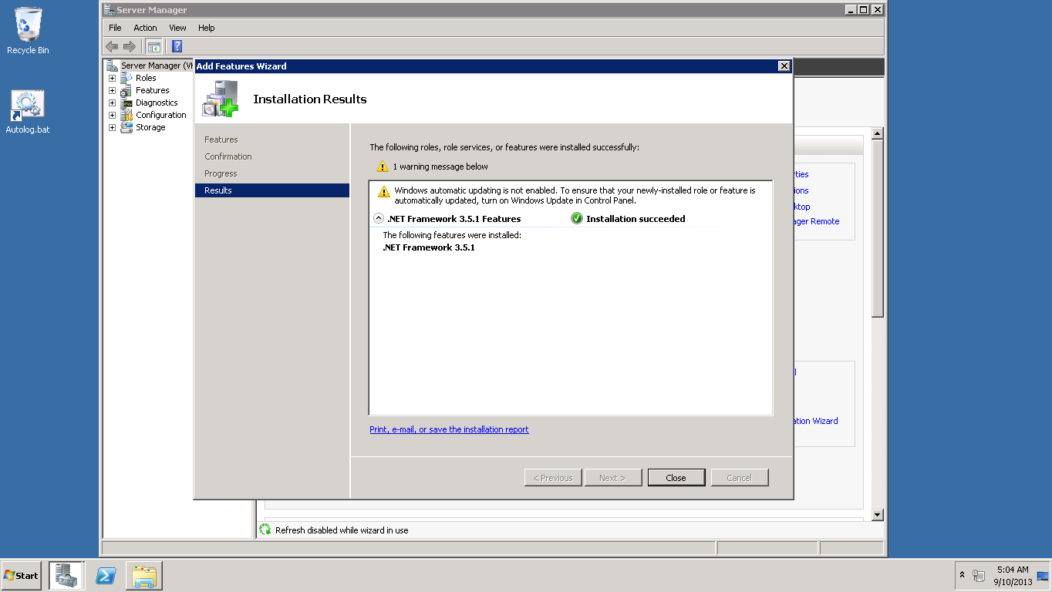

Installed successfully.

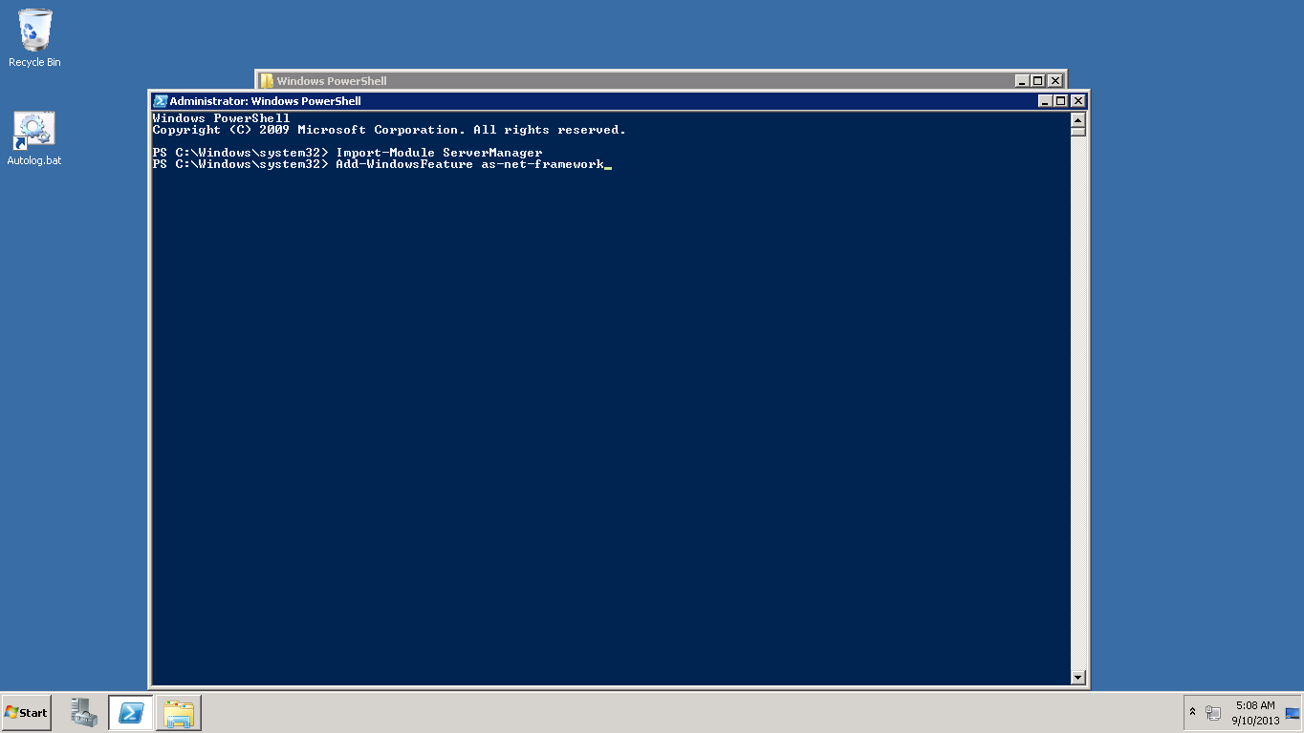

Enter required commands in command prompt.

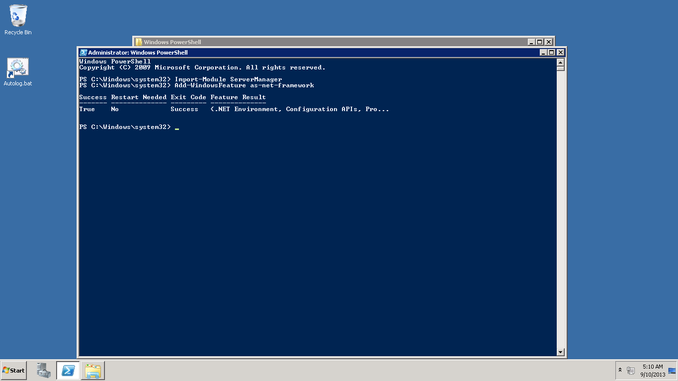

You will get it as above.

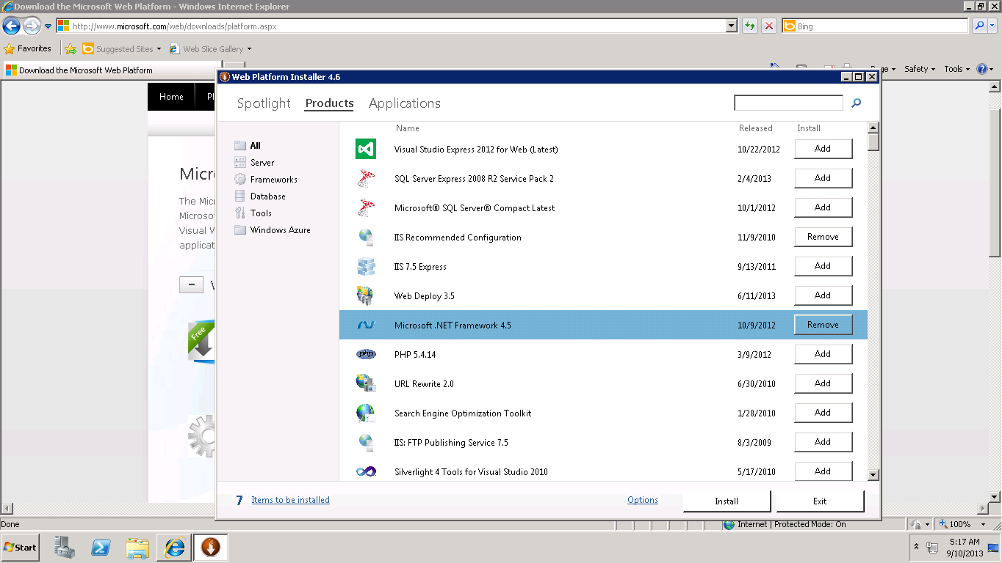

Install IIS configuration and .net4.5

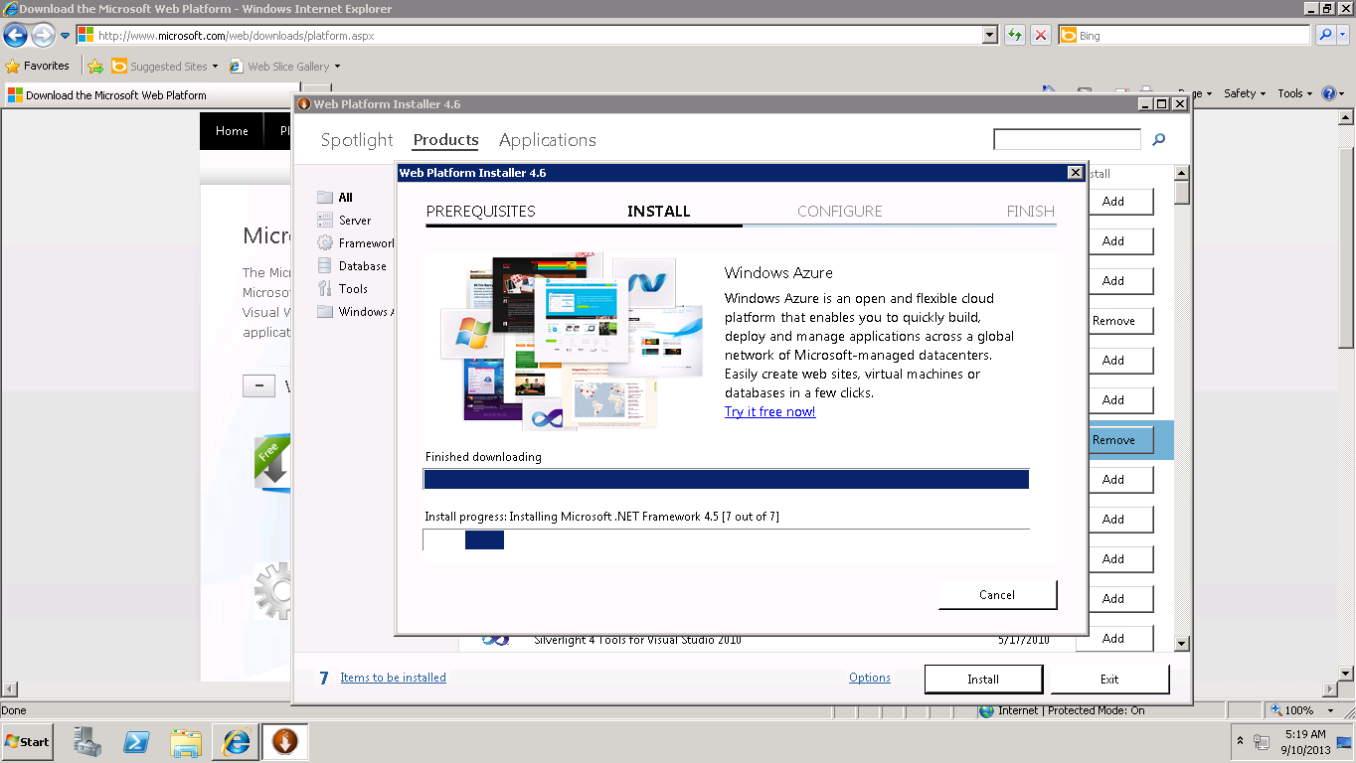

Installing.

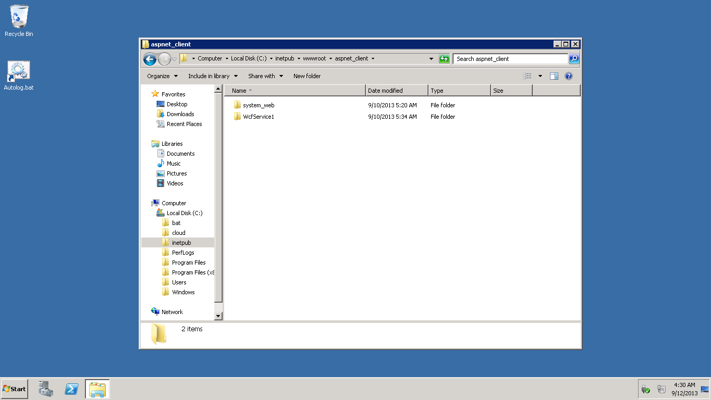

Wcfservice is kept in the required path.

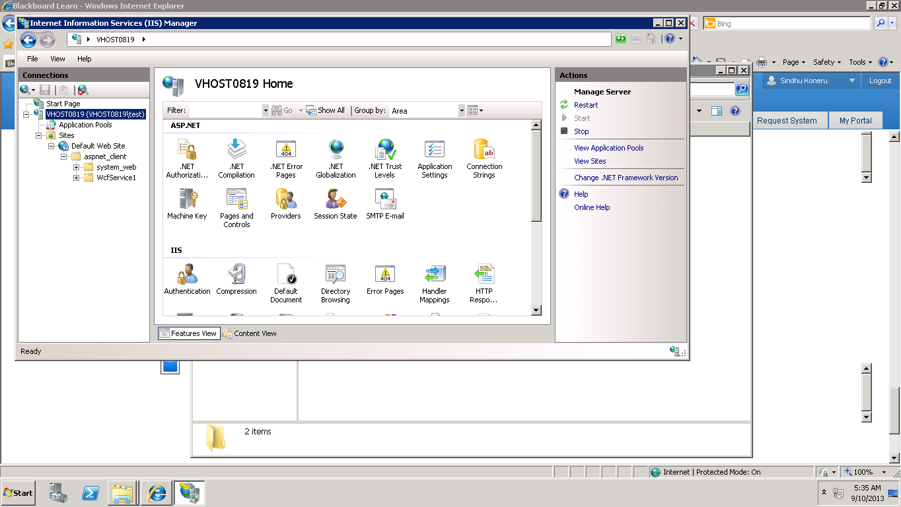

The iis manager is opened.

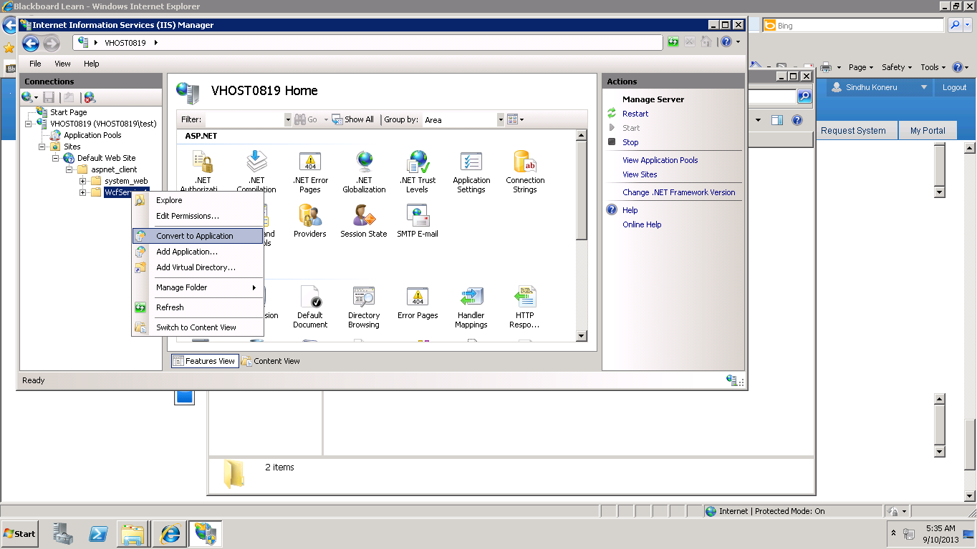

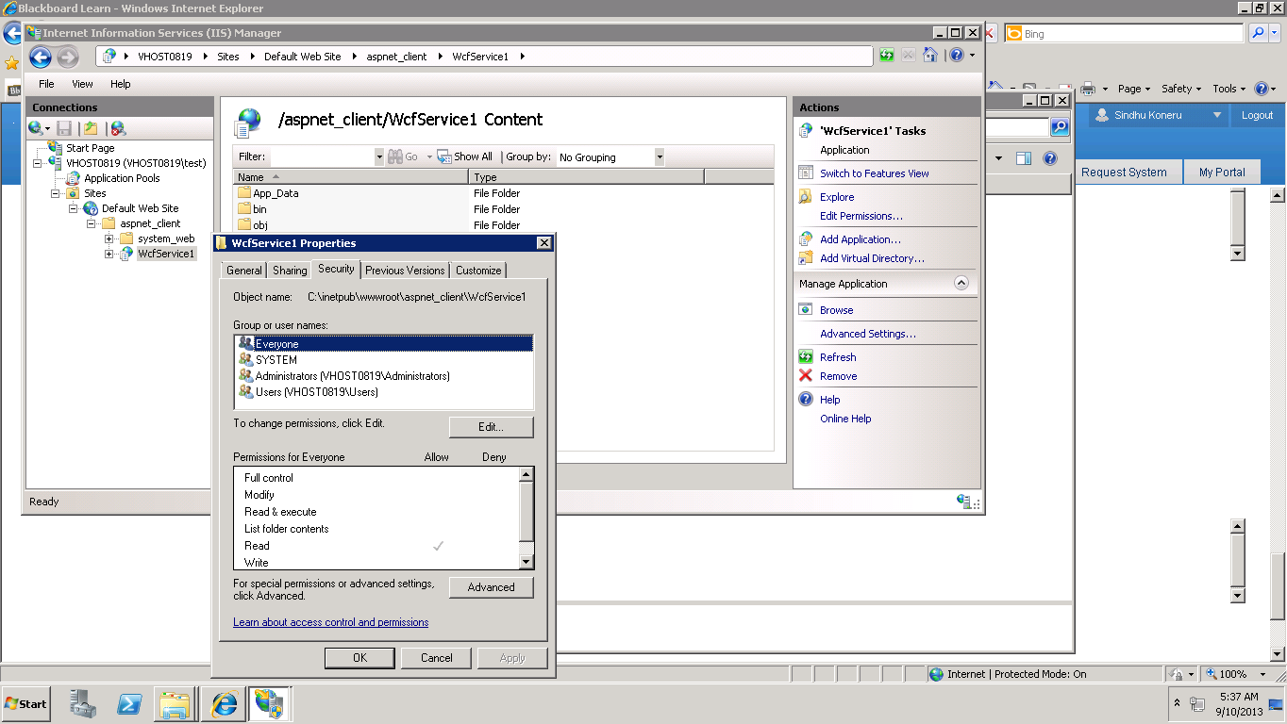

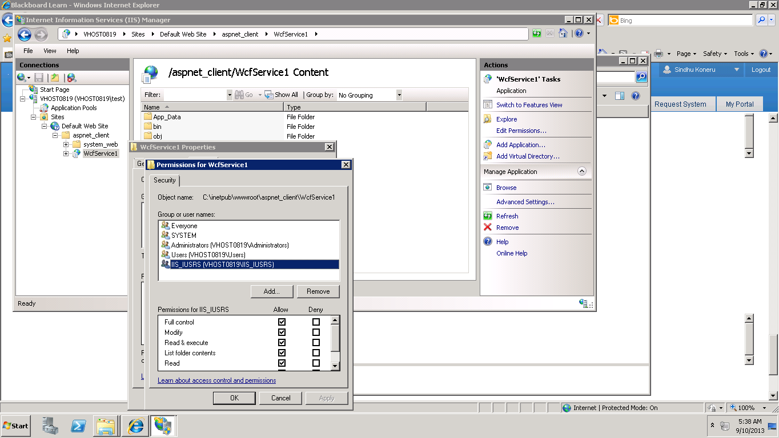

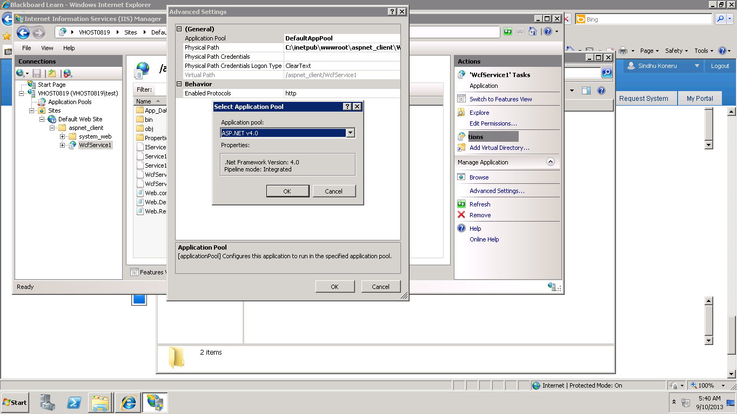

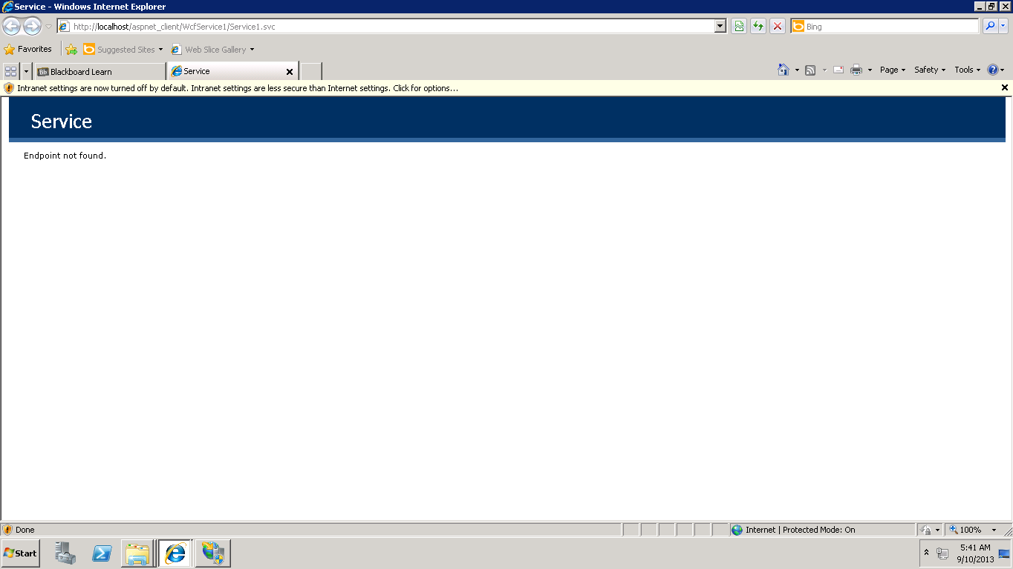

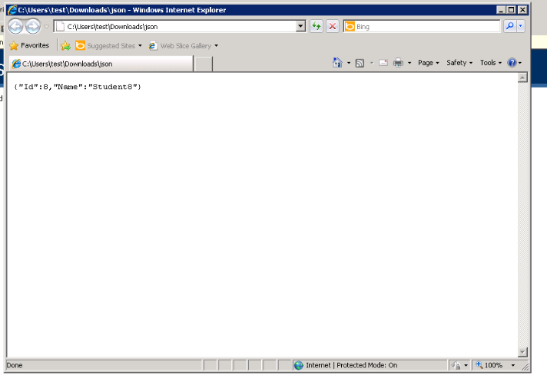

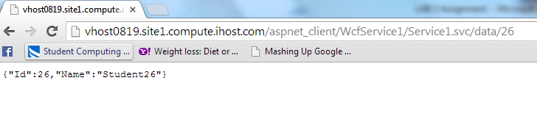

Opening in local host.